AI Assistant Assignment-11.1
V. Rachana
2303A52335 Batch-44
Task Description #1 – Stack Implementation
Task: Use AI to generate a Stack class with push, pop, peek, and is_empty methods.
Sample Input Code:
class Stack: pass
Expected Output:
• A functional stack implementation with all required methods and
Docstrings
Prompt:
Generate a Python Stack class using a list with push, pop, peek, and is_empty methods including docstrings
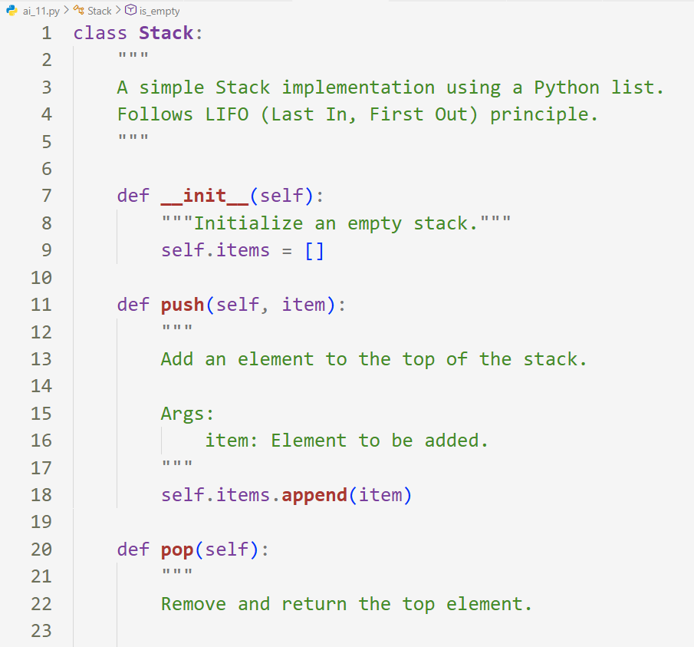
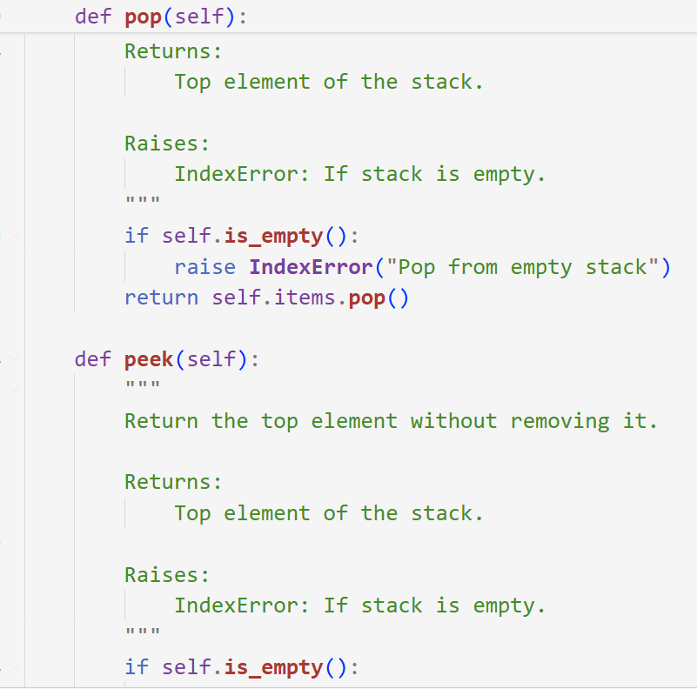
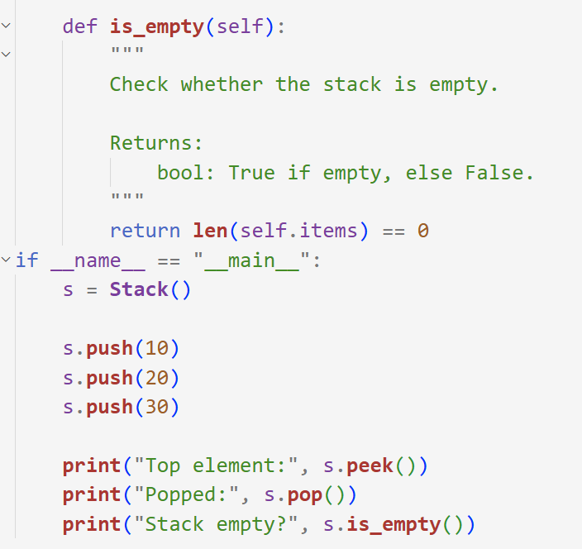
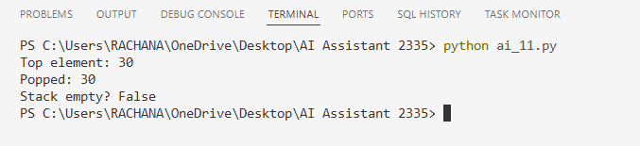
Description
Using AI, a Stack data structure was generated in Python.
The AI created a class named Stack implementing core stack operations such as push, pop, peek, and is_empty following the LIFO (Last In, First Out) principle.
The implementation uses a Python list to store elements and includes proper docstrings for better readability and documentation.
Error handling was also included to manage operations on an empty stack.
Task Description #2 – Queue Implementation
Task: Use AI to implement a Queue using Python lists.
Sample Input Code:
class Queue:
pass
Expected Output:
• FIFO-based queue class with enqueue, dequeue, peek, and size
Methods
Prompt:
Create a Python Queue class using lists with enqueue, dequeue, peek, and size methods and proper documentation.
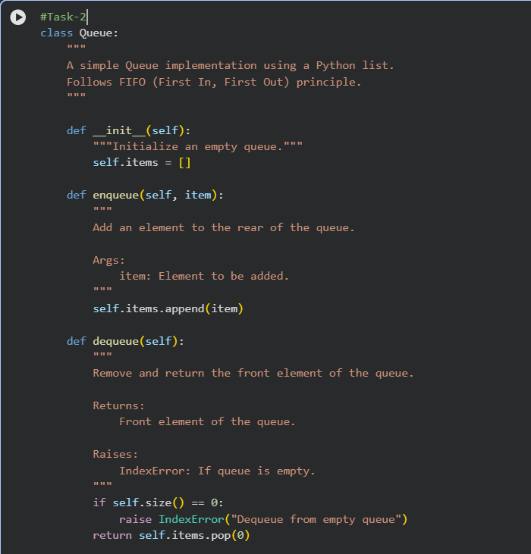
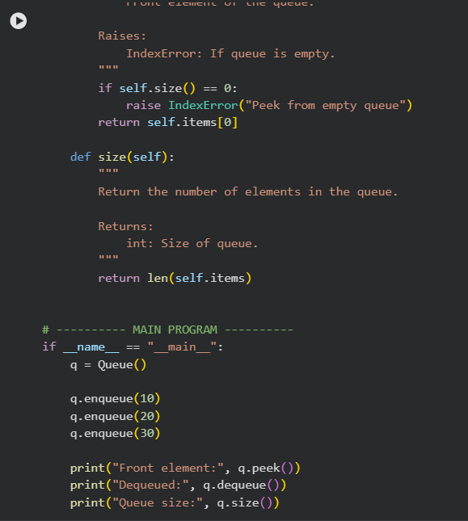

Description
Using AI, a Queue data structure was implemented in Python following the FIFO (First In, First Out) principle.
The AI generated a Queue class using a Python list as the internal storage.
The implementation includes basic queue operations such as enqueue, dequeue, peek, and size.
Proper docstrings were added for clarity and error handling was included to manage operations on an empty queue.
Task Description #3 – Linked List
Task: Use AI to generate a Singly Linked List with insert and display
methods.
Sample Input Code:
class Node: pass
class LinkedList: pass
Expected Output:
• A working linked list implementation with clear method
documentation.
Prompt:
Generate a singly linked list in Python with Node and LinkedList classes including insert and display methods with docstrings.

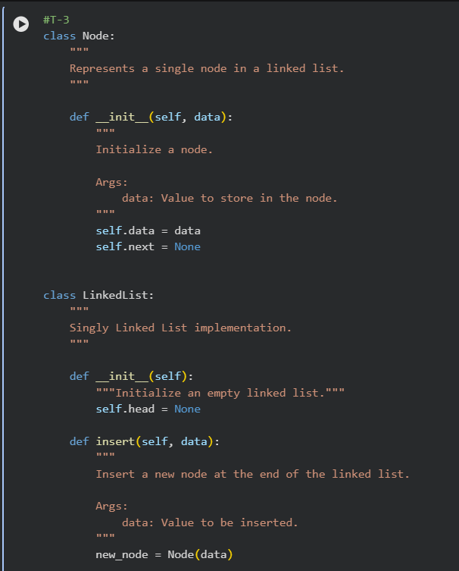
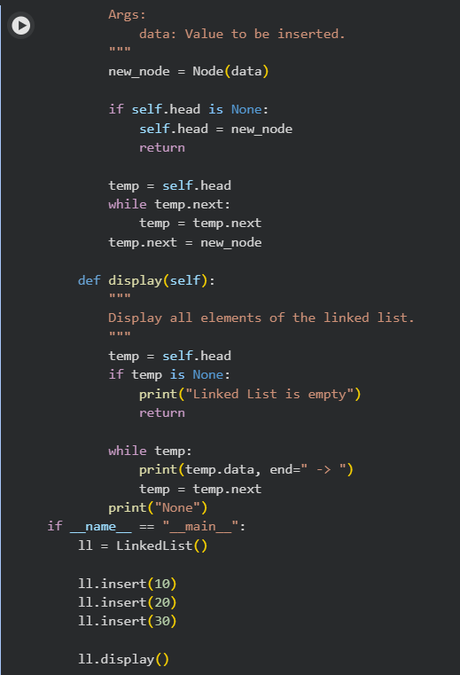

Description
Using AI, a Singly Linked List was generated in Python.
The implementation includes two classes: Node and LinkedList.
Each node stores data and a reference to the next node.
The linked list supports basic operations such as insert (adding nodes at the end) and display (traversing and printing elements).
Proper method documentation and clean structure were included to improve readability and understanding.
Task Description #4 – Binary Search Tree (BST)
Task: Use AI to create a BST with insert and in-order traversal methods.
Sample Input Code:
class BST: pass
Expected Output:
• BST implementation with recursive insert and traversal methods.
Prompt:
Create a Binary Search Tree class in Python with recursive insert and in-order traversal methods including clear documentation.
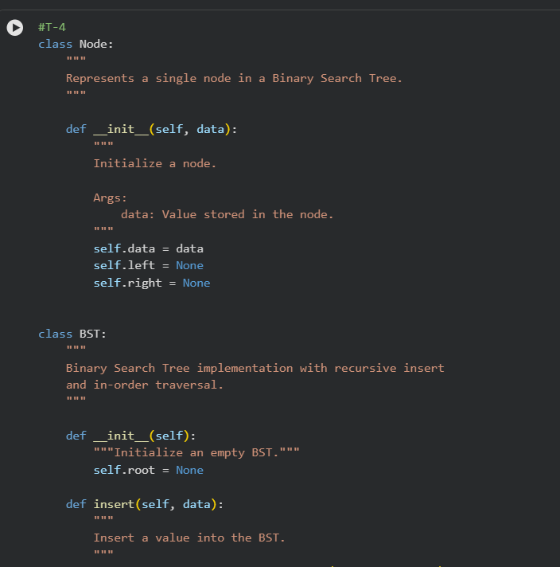
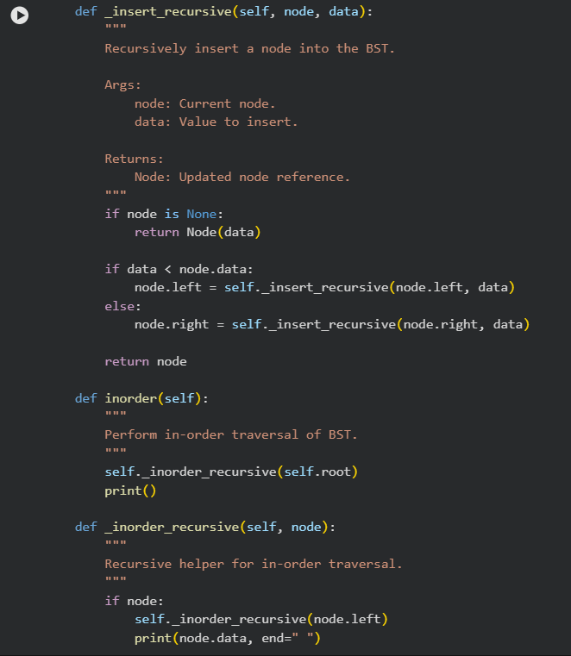
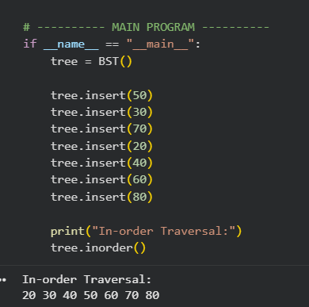
Explanation:
BST stores data hierarchically where smaller values go left and larger values go right using recursive insert and in-order traversal.
Task Description #5 – Hash Table
Task: Use AI to implement a hash table with basic insert, search, and
delete methods.
Sample Input Code:
class HashTable: pass
Expected Output:
• Collision handling using chaining, with well-commented methods
Prompt:
Implement a HashTable in Python using chaining with insert, search, and delete methods and proper comments.
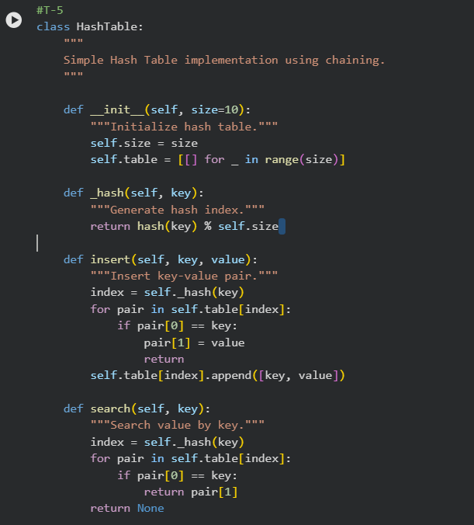

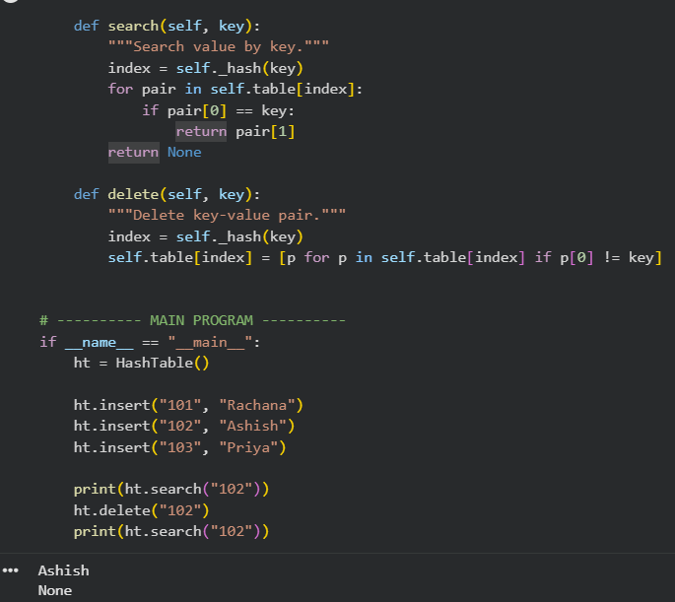
Explanation:
Hash table stores key–value pairs using hashing and handles collisions using chaining for efficient insert, search, and delete operations.
Task Description #6 – Graph Representation
Task: Use AI to implement a graph using an adjacency list.
Sample Input Code:
class Graph:pass
Expected Output:
• Graph with methods to add vertices, add edges, and display
connections.
Prompt:Generate a Graph class in Python using adjacency list representation with add_vertex, add_edge, and display methods.
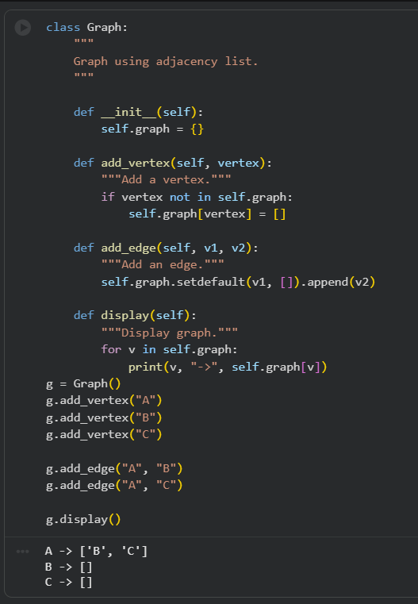
Explanation:
Graph uses an adjacency list to represent vertices and their connections with methods to add vertices, edges, and display relationships.
Task Description #7 – Priority Queue
Task: Use AI to implement a priority queue using Python’s heapq
module.
Sample Input Code:
class PriorityQueue: pass
Expected Output:
• Implementation with enqueue (priority), dequeue (highest priority), and display methods.
Prompt:
Create a Priority Queue in Python using heapq with enqueue, dequeue, and display methods including docstrings.
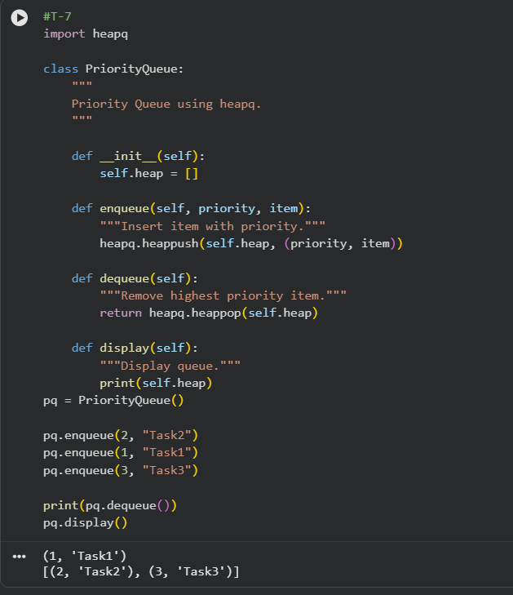
Explanation:
Priority queue processes elements based on priority using a heap structure instead of insertion order.
Task Description #8 – Deque
Task: Use AI to implement a double-ended queue using
collections.deque.
Sample Input Code:
class DequeDS:
pass
Expected Output:
• Insert and remove from both ends with docstrings.
Prompt:
Implement a Deque class in Python using collections.deque with insert and remove operations from both ends.
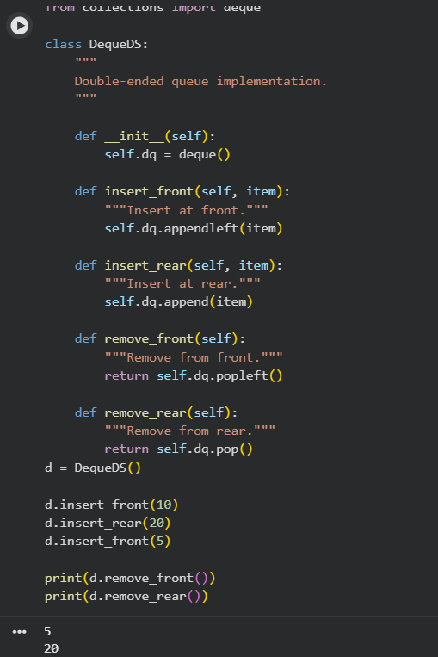
Explanation:
Deque allows insertion and deletion from both front and rear ends efficiently using collections.deque.
Task Description #9 Real-Time Application Challenge – Choose the
Right Data Structure
Scenario:
Your college wants to develop a Campus Resource Management System
that handles:
1. Student Attendance Tracking – Daily log of students
entering/exiting the campus.
2. Event Registration System – Manage participants in events with
quick search and removal.
3. Library Book Borrowing – Keep track of available books and their
due dates.
4. Bus Scheduling System – Maintain bus routes and stop
connections.
5. Cafeteria Order Queue – Serve students in the order they arrive.
Student Task:
• For each feature, select the most appropriate data structure from
the list below:
o Stack
o Queue
o Priority Queue
o Linked List
o Binary Search Tree (BST)
o Graph
o Hash Table
o Deque
• Justify your choice in 2–3 sentences per feature.
• Implement one selected feature as a working Python program with
AI-assisted code generation.
Expected Output:
• A table mapping feature → chosen data structure → justification.
• A functional Python program implementing the chosen feature
with comments and docstrings.
Prompt:
Create a cafeteria order queue system in Python using FIFO logic with add, serve, and display methods.

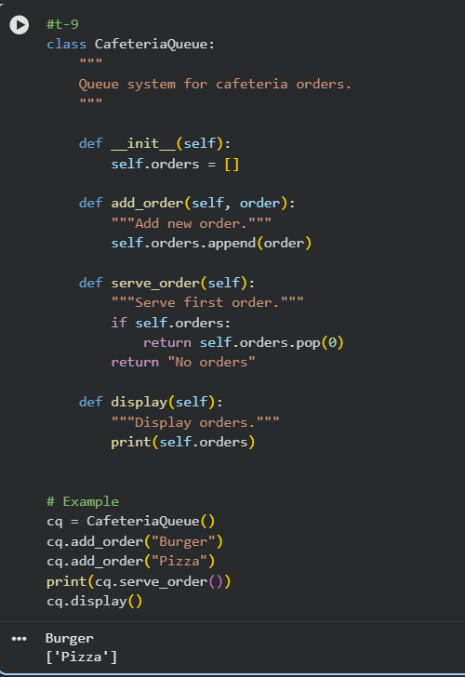

Explanation:
Cafeteria order handling uses a queue to serve students in FIFO order for fair processing.

Task Description #10: Smart E-Commerce Platform – Data Structure
Challenge
An e-commerce company wants to build a Smart Online Shopping System
with:
1. Shopping Cart Management – Add and remove products
dynamically.
2. Order Processing System – Orders processed in the order they are
placed.
3. Top-Selling Products Tracker – Products ranked by sales count.
4. Product Search Engine – Fast lookup of products using product ID.
5. Delivery Route Planning – Connect warehouses and delivery
locations.
Student Task:
• For each feature, select the most appropriate data structure from
the list below:
o Stack
o Queue
o Priority Queue
o Linked List
o Binary Search Tree (BST)
o Graph
o Hash Table
o Deque
• Justify your choice in 2–3 sentences per feature.
• Implement one selected feature as a working Python program with
AI-assisted code generation.
Expected Output:
• A table mapping feature → chosen data structure → justification.
• A functional Python program implementing the chosen feature
with comments and docstrings.
Prompt:
Generate an order processing queue in Python with place_order, process_order, and display_orders methods including comments.
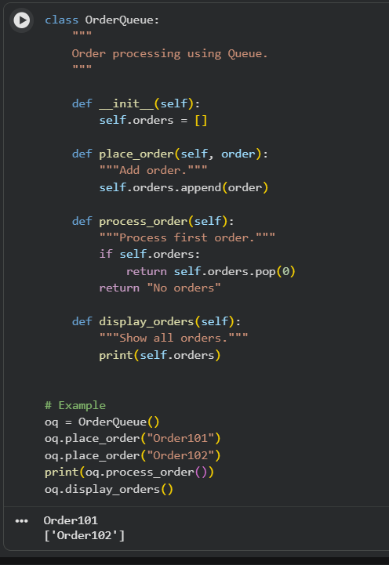
Explanation:
Order processing uses a queue so orders are handled in the same order they are placed.

